**Different Test Scenarios to be tested and validated** :-

1) Bundle Validation :- Validation of Project bundle in Automation Node.

2) Recipes check in Bitbucket to Automation node (Making changes in Dataiku and pushing it to bitbucket).

3) checking recipes in dataiku after updating in Bitbucket.

4) checking recipes and reverting back to older recipes.

**1.Bundle validation :-**

Creating a Bundle

Before doing changes in recipe..let’s take Test_size as 0.25 and after making it change to 0.50.

After doing changes in code recipe as Test size as 0.50 , we see Final Test Output as 0.50 as we can see change in recipe here in below snapshot.

**2.Recipes check in Bitbucket to Automation node :**

Here the objective is when we push our model to bitbucket. We need to check whether the recipes are updated or not , through automation node.

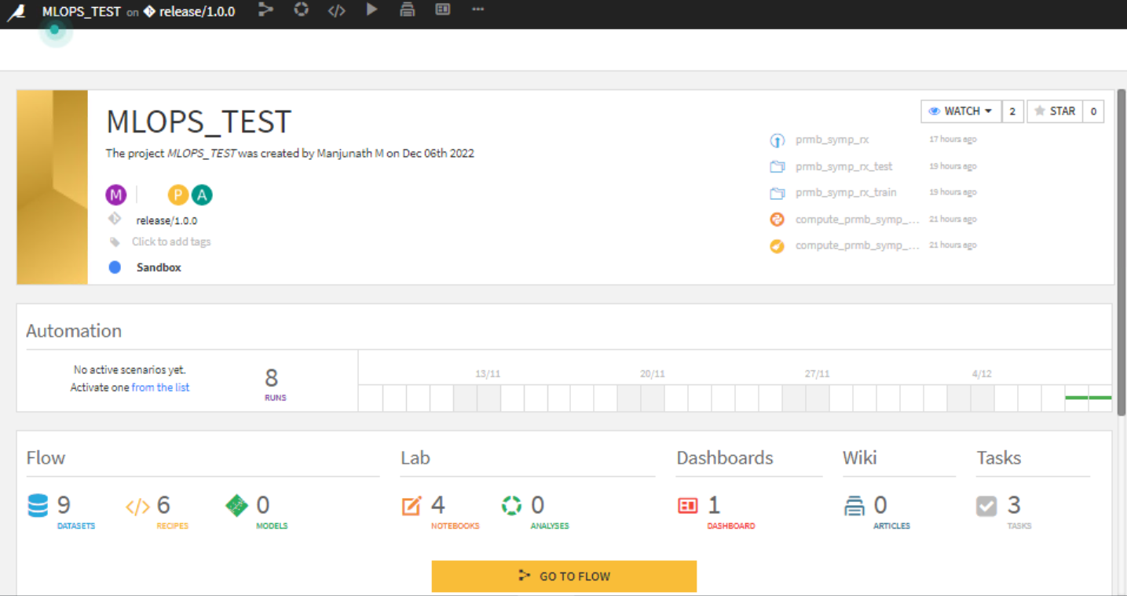

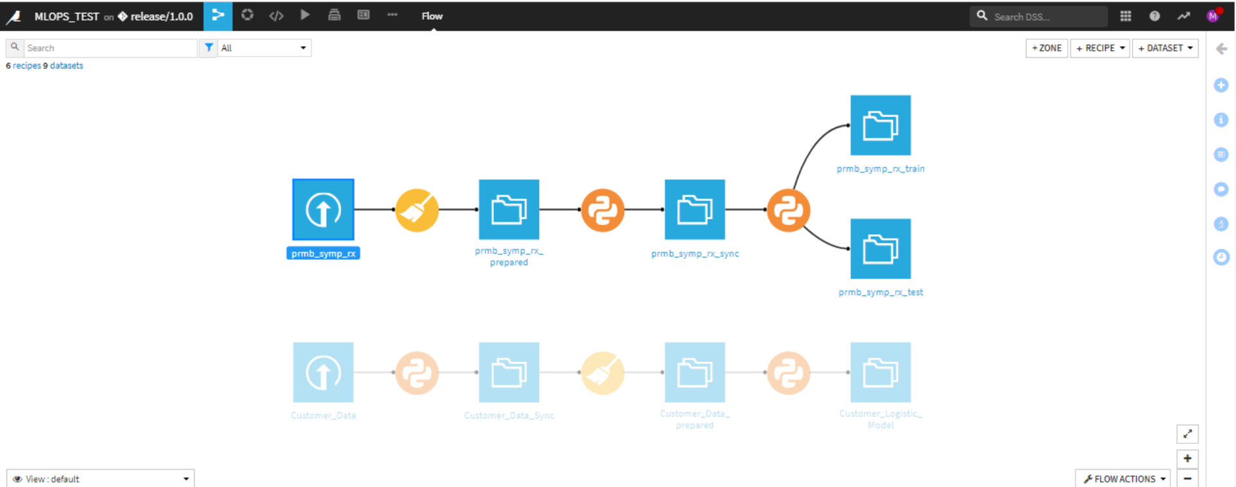

**Performing changes in the recipe file and Python Notebook.**

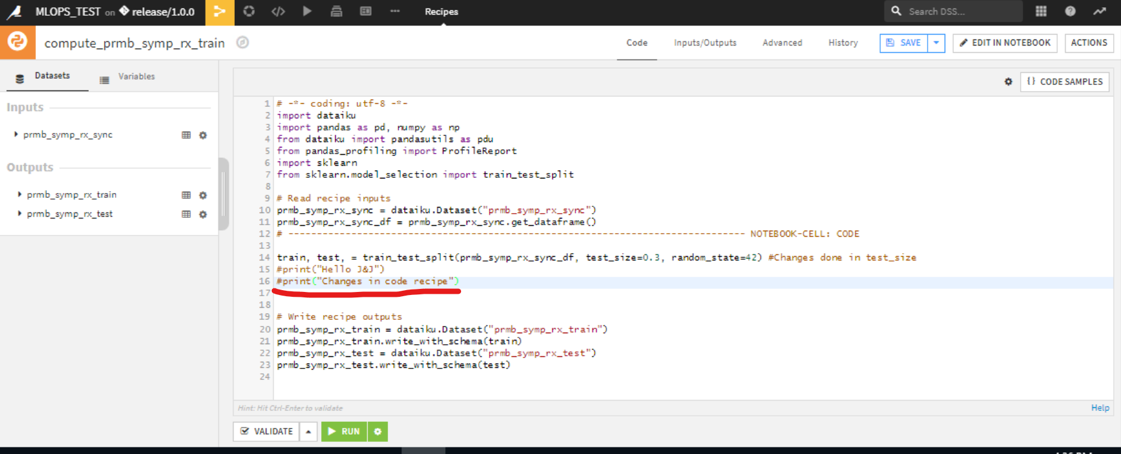

Making Changes in Code recipes.

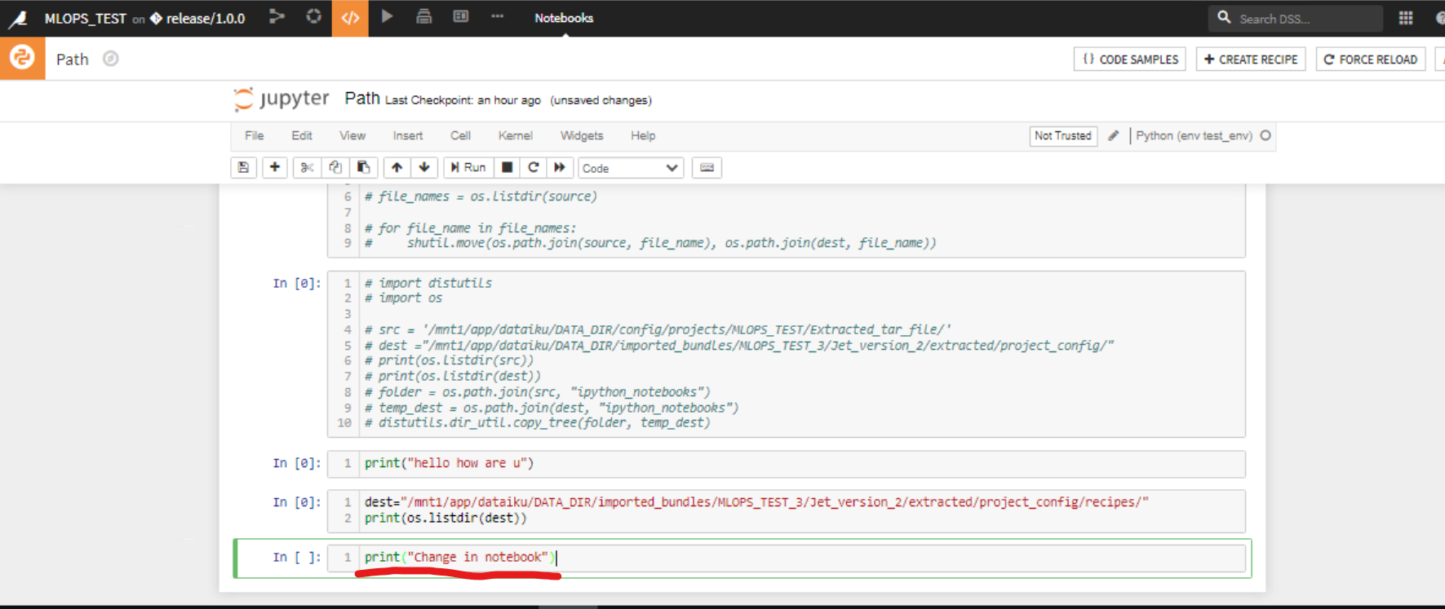

Yes when we push the code able see all the recipes in the bitbucket folder

Recipes folder

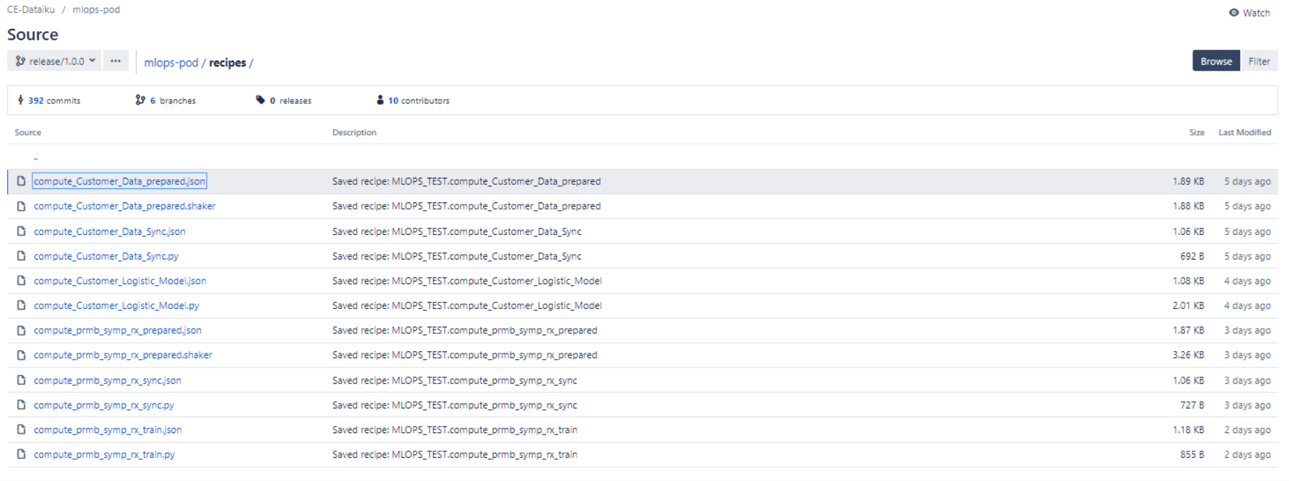

Note Book folder

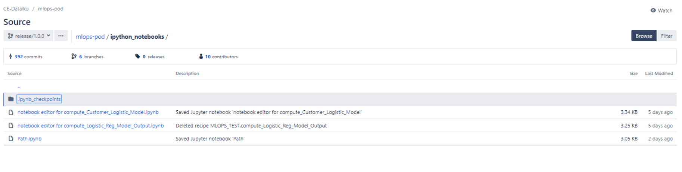

**Triggering the pipeline automatically for repo changes. Pipeline will get triggered automatically once there are any changes pushed to bitbucket**.

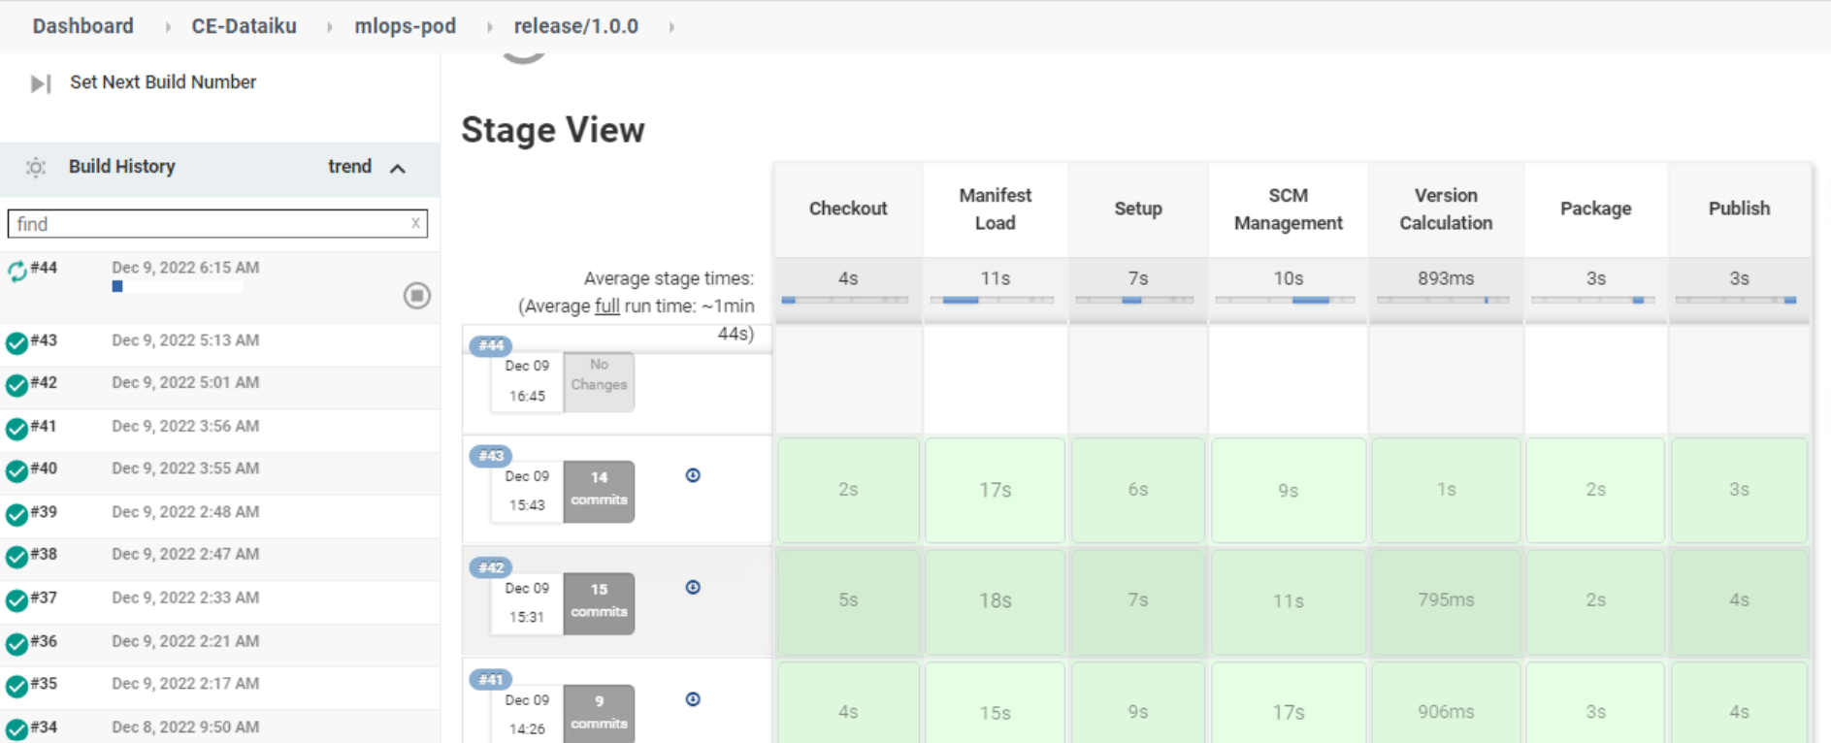

We can now see the changes done for recipe file and python notebook

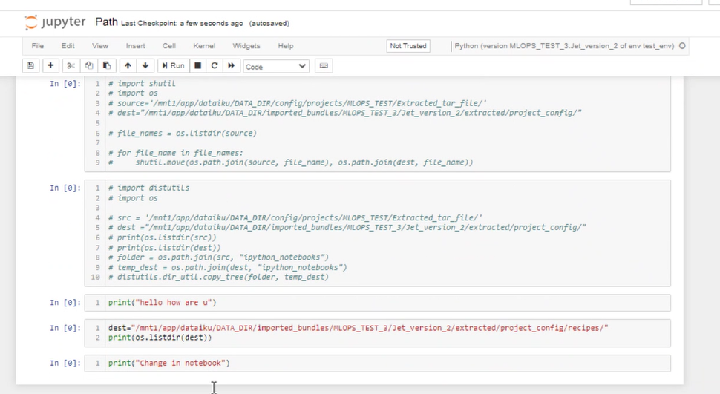

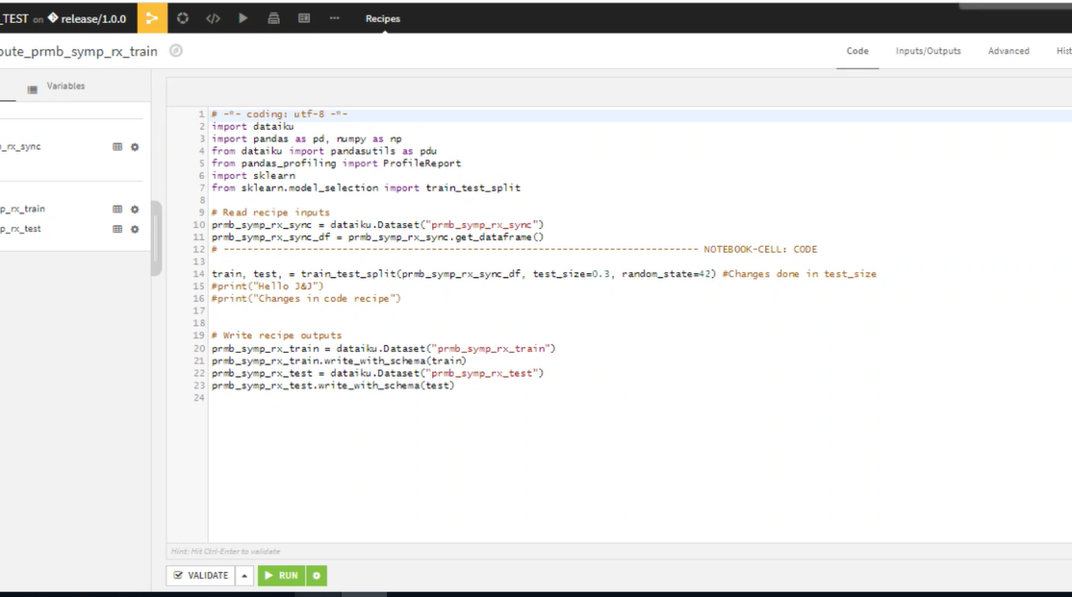

**3.checking recipes and reverting back to older recipes:**

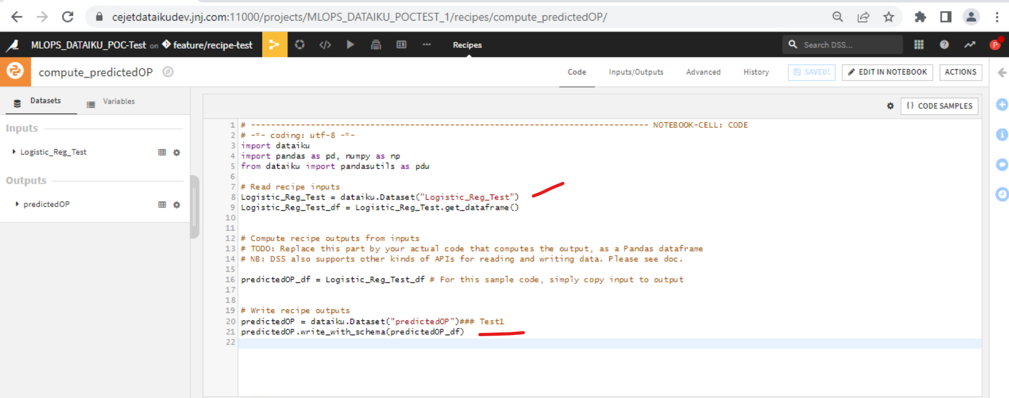

From model we have python recipe open the python recipe and check the highlighted lines in next slides we are going to change this and reverting back to the same version lets consider this the older version.

Here I am pushing my code to bitbucket by clicking the Push

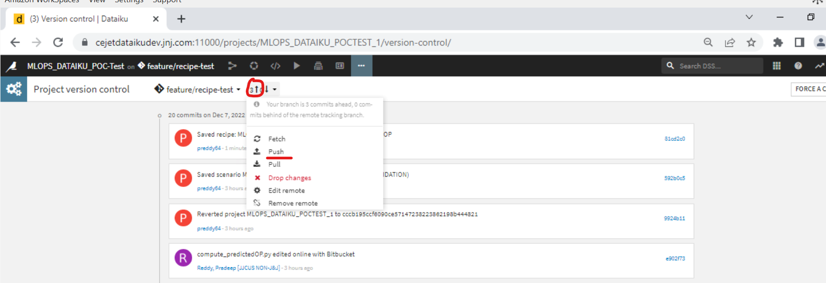

Clicking on the recipe and update your changes

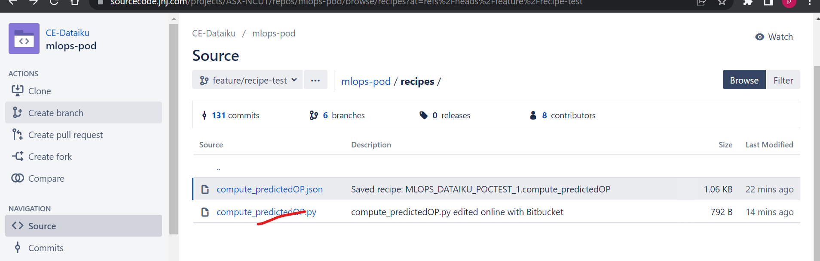

Clicking on the edit and make your changes.

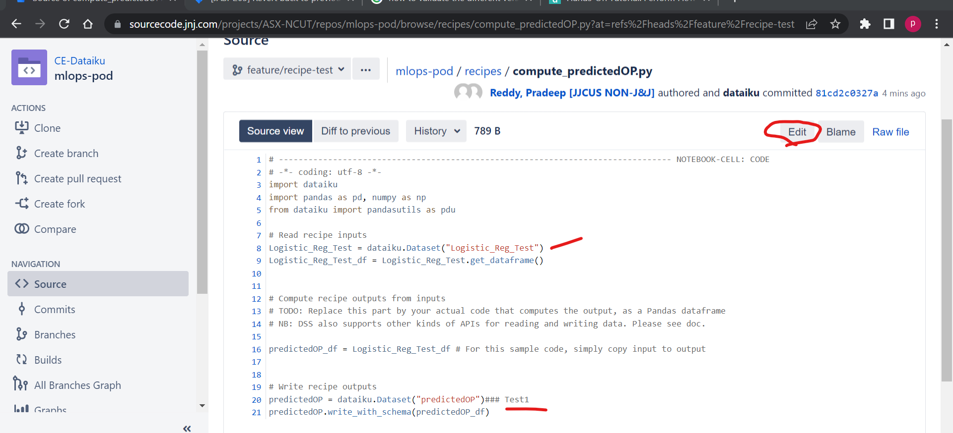

**4. checking recipes and reverting back to older recipes :**

Updating the recipe in Bitbucket

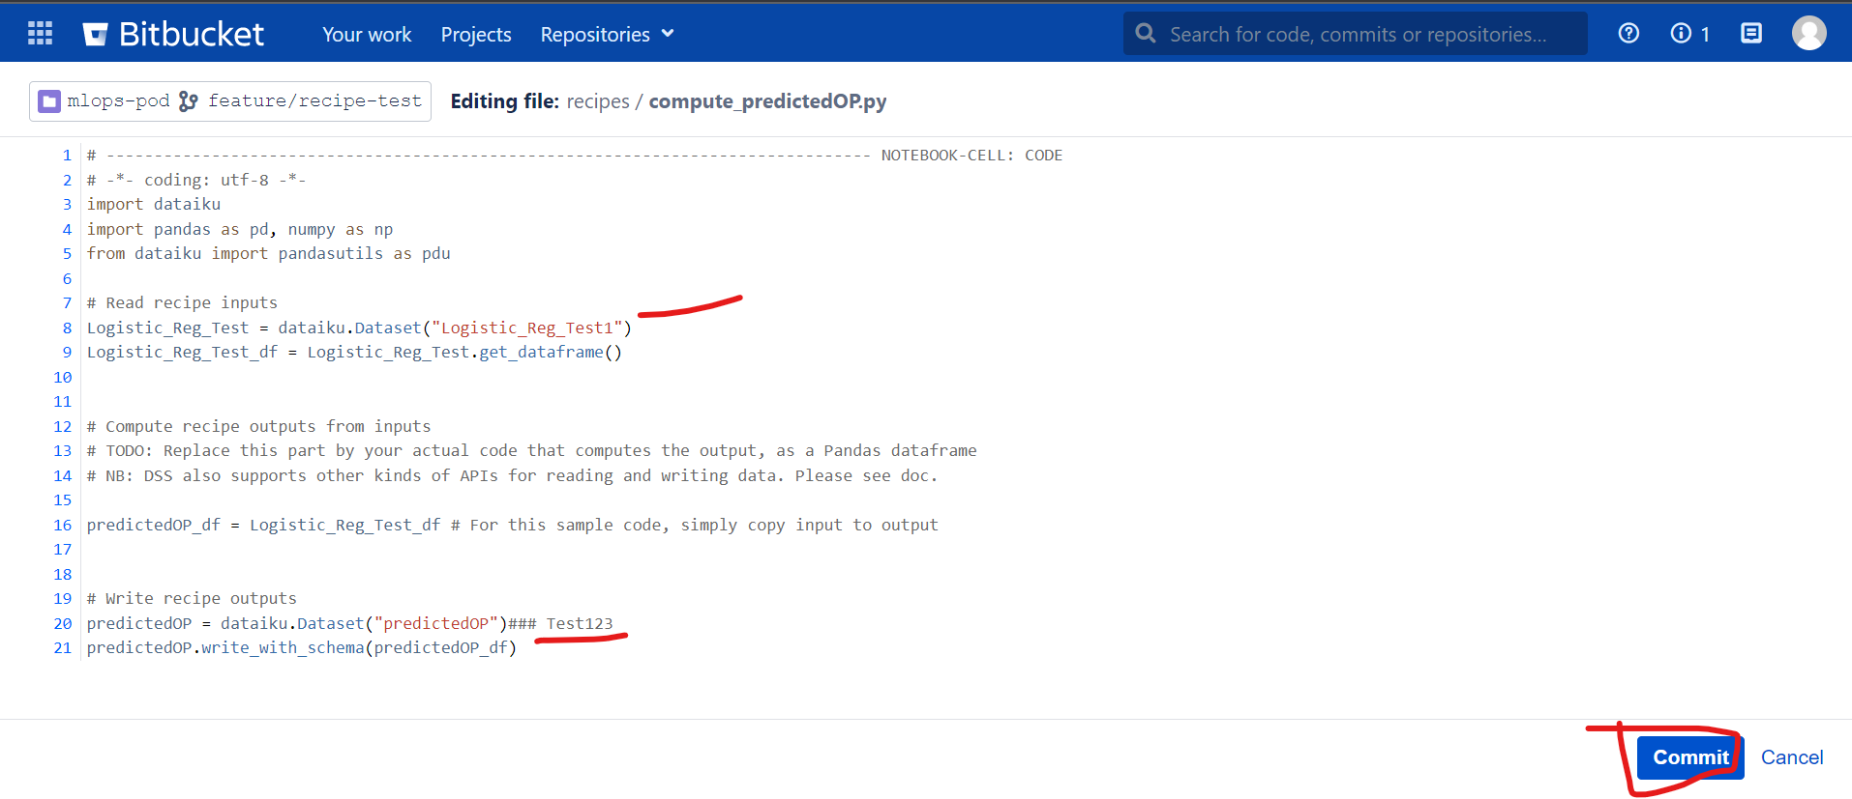

Pulling all updated recipes from Bitbucket

As we can see or changes are reflected, which we did in the bitbucket

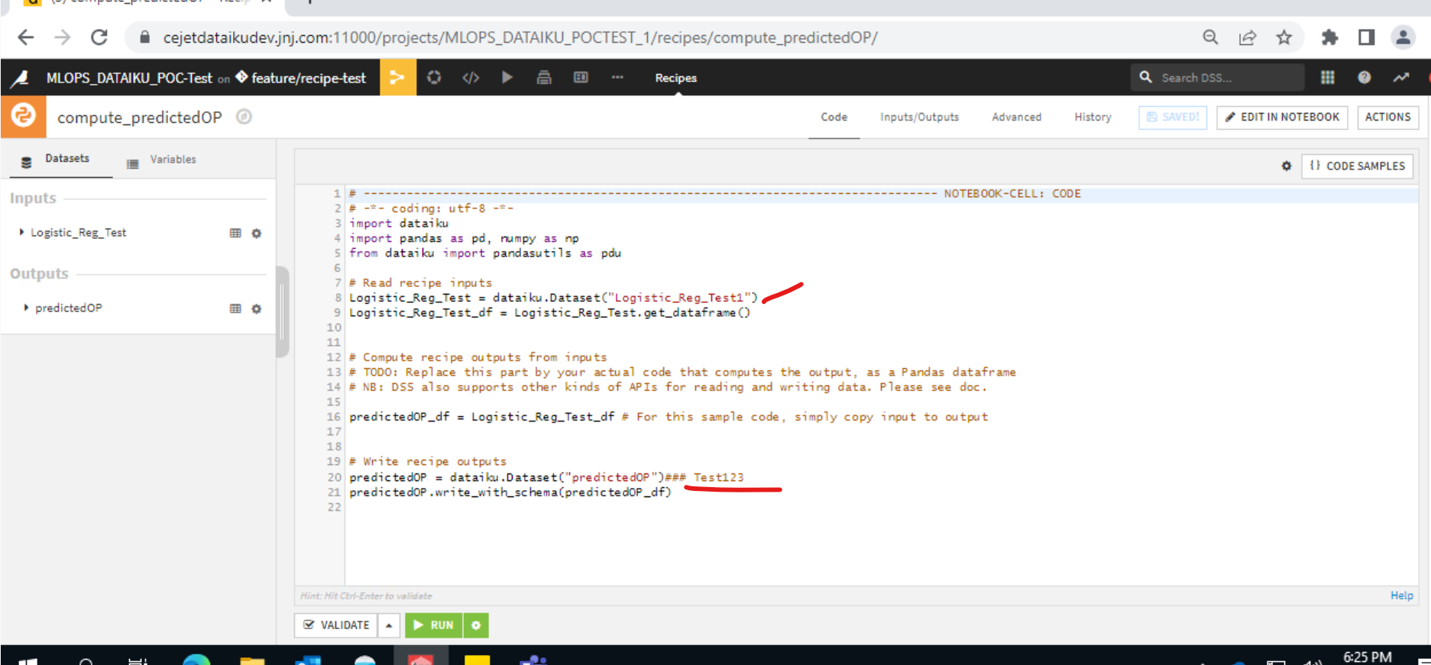

Now we are reverting back to old recipe or older version for that click on the older version of recipe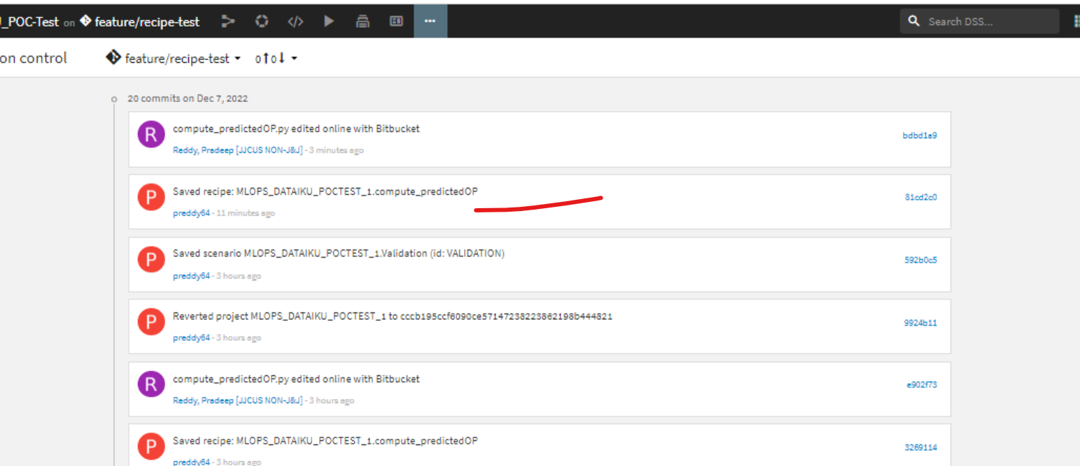

By selecting revert to the revision it will reverted to the older version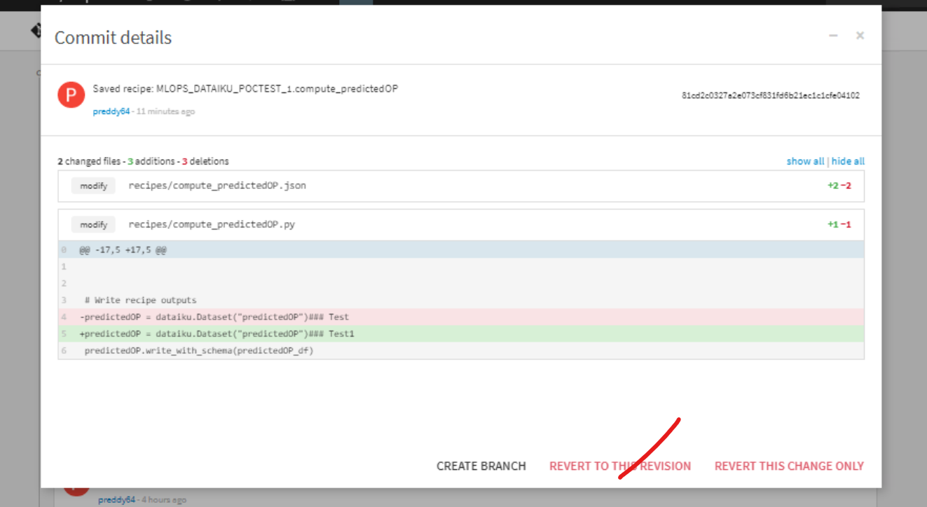

Click on confirm button

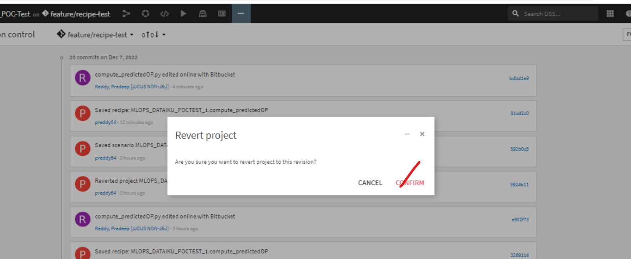

It will be revert back to the older version

